Week 1 GOAL

I2.1. Explain what SQL is used for:
QL (Structured Query Language) is a language used to interact with relational databases. It allows users to:
- Retrieve Data using queries (SELECT).
- Modify Data using commands (INSERT, UPDATE, DELETE).
- Define Database Structures (CREATE TABLE, ALTER TABLE, DROP TABLE).
- Manage Database Access (GRANT, REVOKE).
Example:
- Retrieving all products:
SELECT * FROM Product;
- Adding a new product:
INSERT INTO Product (Product_No, Description, Price, Warehouse_No)
VALUES ('P006', 'Hats', 30, 'W020');

I2.2. Discuss, using examples, the difference between DDL and DML:
SQL is categorized into different types, mainly DDL (Data Definition Language) and DML (Data Manipulation Language).
 | Purpose |  | Example Usage
  Type
  Example Commands
DDL (Data Definition Language) | Defines and modifies the structure of database objects | CREATE, ALTER, DROP | Creating a new table: CREATE TABLE Product (Product_No VARCHAR(10), Description TEXT, Price DECIMAL(10,2), Warehouse_No VARCHAR(10));
DML (Data Manipulation Language) | Modifies and queries the data stored in the database | SELECT, INSERT, UPDATE, DELETE | Retrieving product details: SELECT * FROM Product;

I2.3. Explain the syntax and purpose of the select command:
- Purpose:
The SELECT command retrieves data from a database table.
- Syntax:
SELECT column1, column2 FROM table_name WHERE condition;
- Examples: Retrieve all products from the Product table:

- SELECT * FROM Product;
- SELECT Product_No, Description, Price FROM Product;
- SELECT * FROM Product WHERE Price > 50;

I2.4. Connect to MySQL Workbench and set up a new connection:

Steps I took in my MySQL Workbench:
- Opened MySQL Workbench.
- Clicked on "New Connection".
- Entered connection details:
  - Connection Name: Give it a name
  - Hostname: localhost (if running locally).
  - Port: 3306 (default MySQL port).
  - Username: root (or another MySQL user).
  - Password: Click "Store in Vault" or enter when prompted.
- Clicked "Test Connection" to verify connectivity.
- Finally Clicked "OK" to save the connection.

Screenshot:
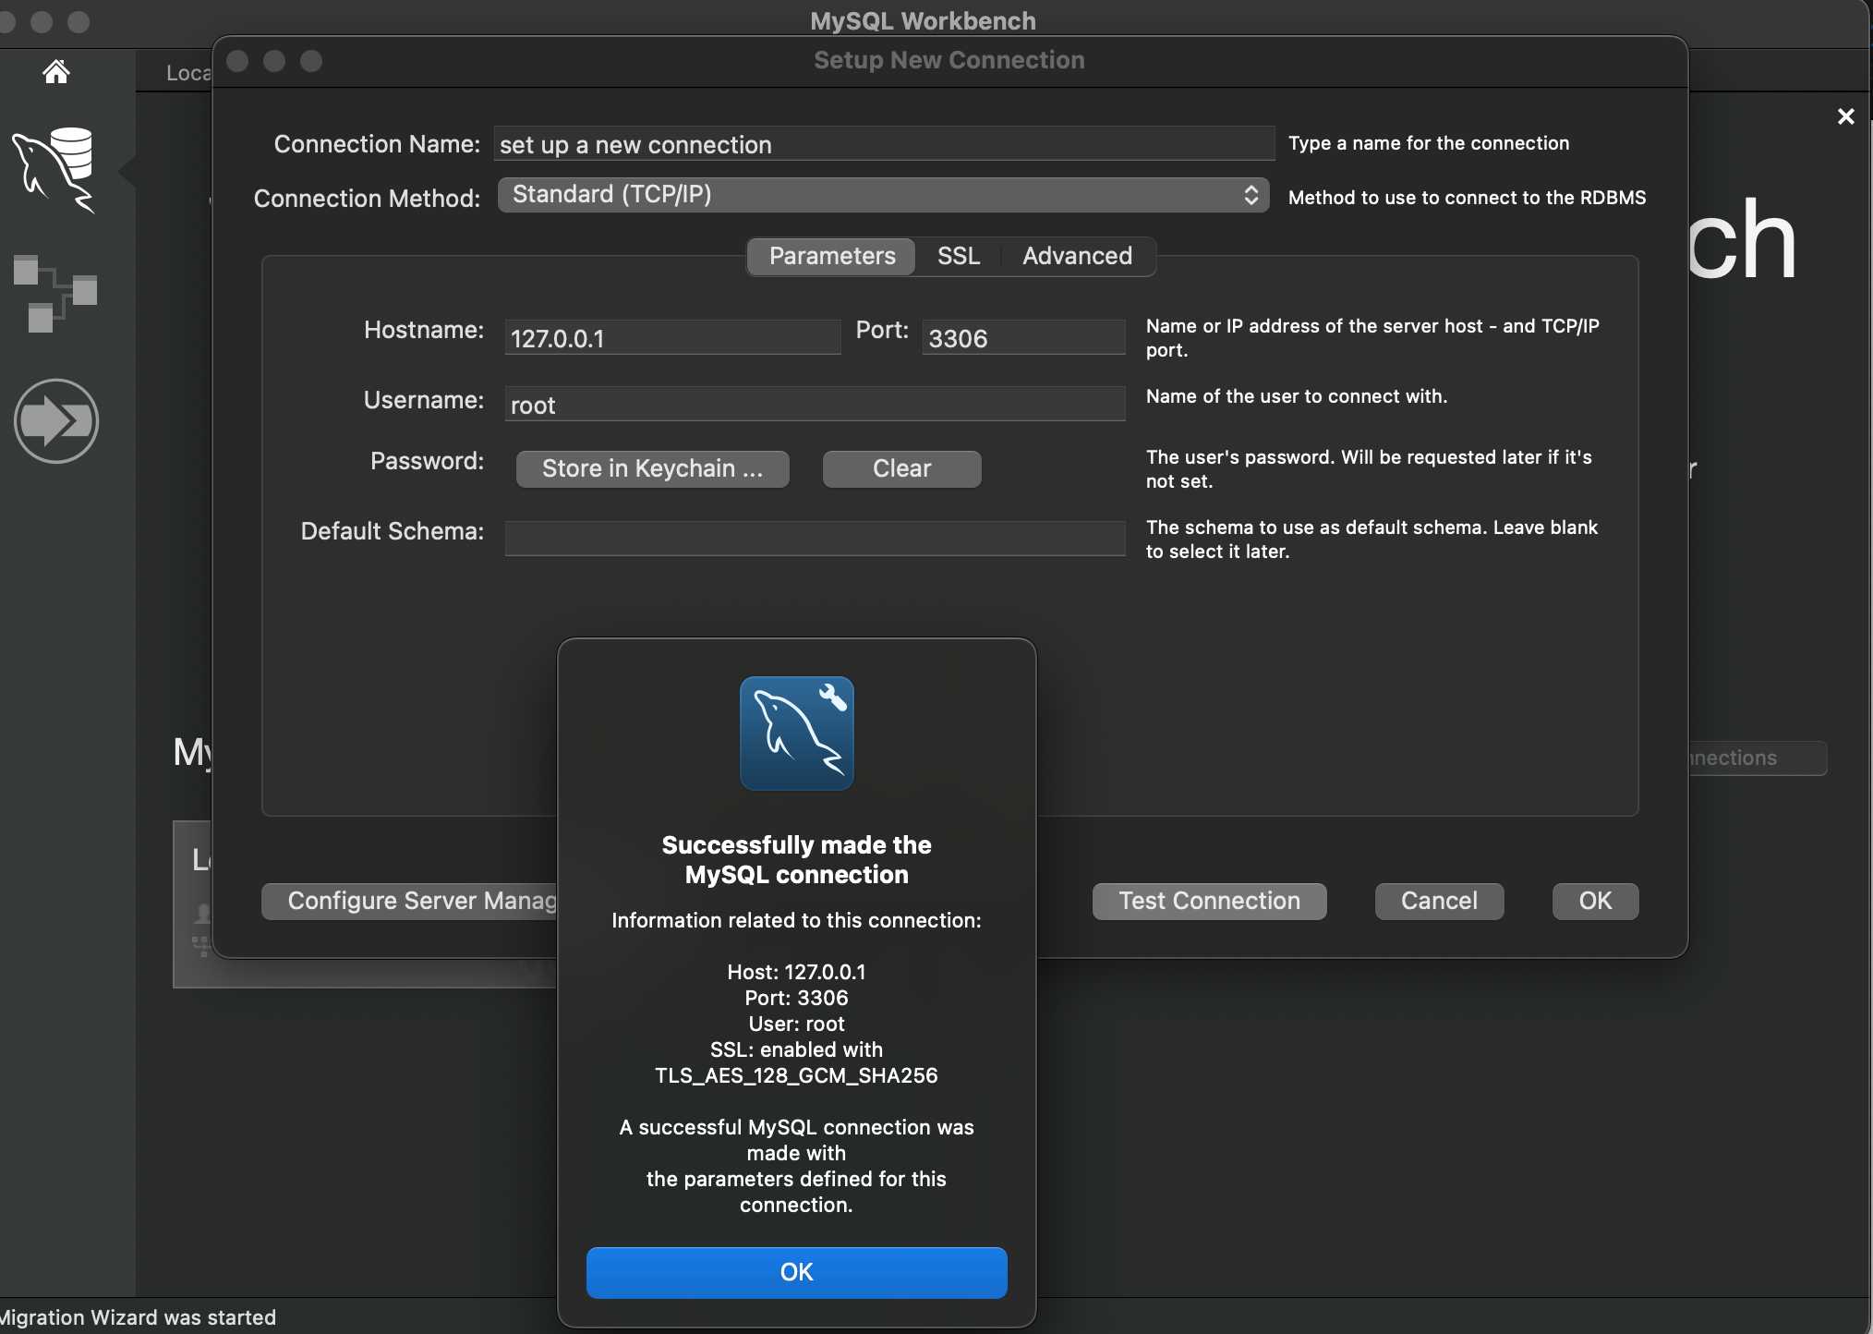

I2.5. Explain how to execute a sql file to create the table given above:

Steps to Execute Product.sql
- Open MySQL Workbench and connect to your database.
- Click on "File" → "Open SQL Script".
- Select the Product.sql file.
- Click "Execute" (lightning bolt icon).
- Verify the table creation by running:
SHOW TABLES;
- Check table is working:
SELECT * FROM Product;

Use the product table to answer the following:
I2.6. Write a SQL query to “List all product details”:
I run SELECT * FROM Product;

Screenshot:

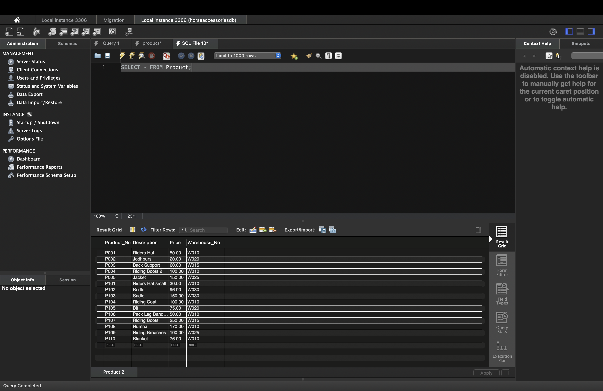

I2.7. Write a SQL query to “List the product number, description and price of each product”:
I run SELECT Product_No, Description, Price FROM Product;
Screenshot:
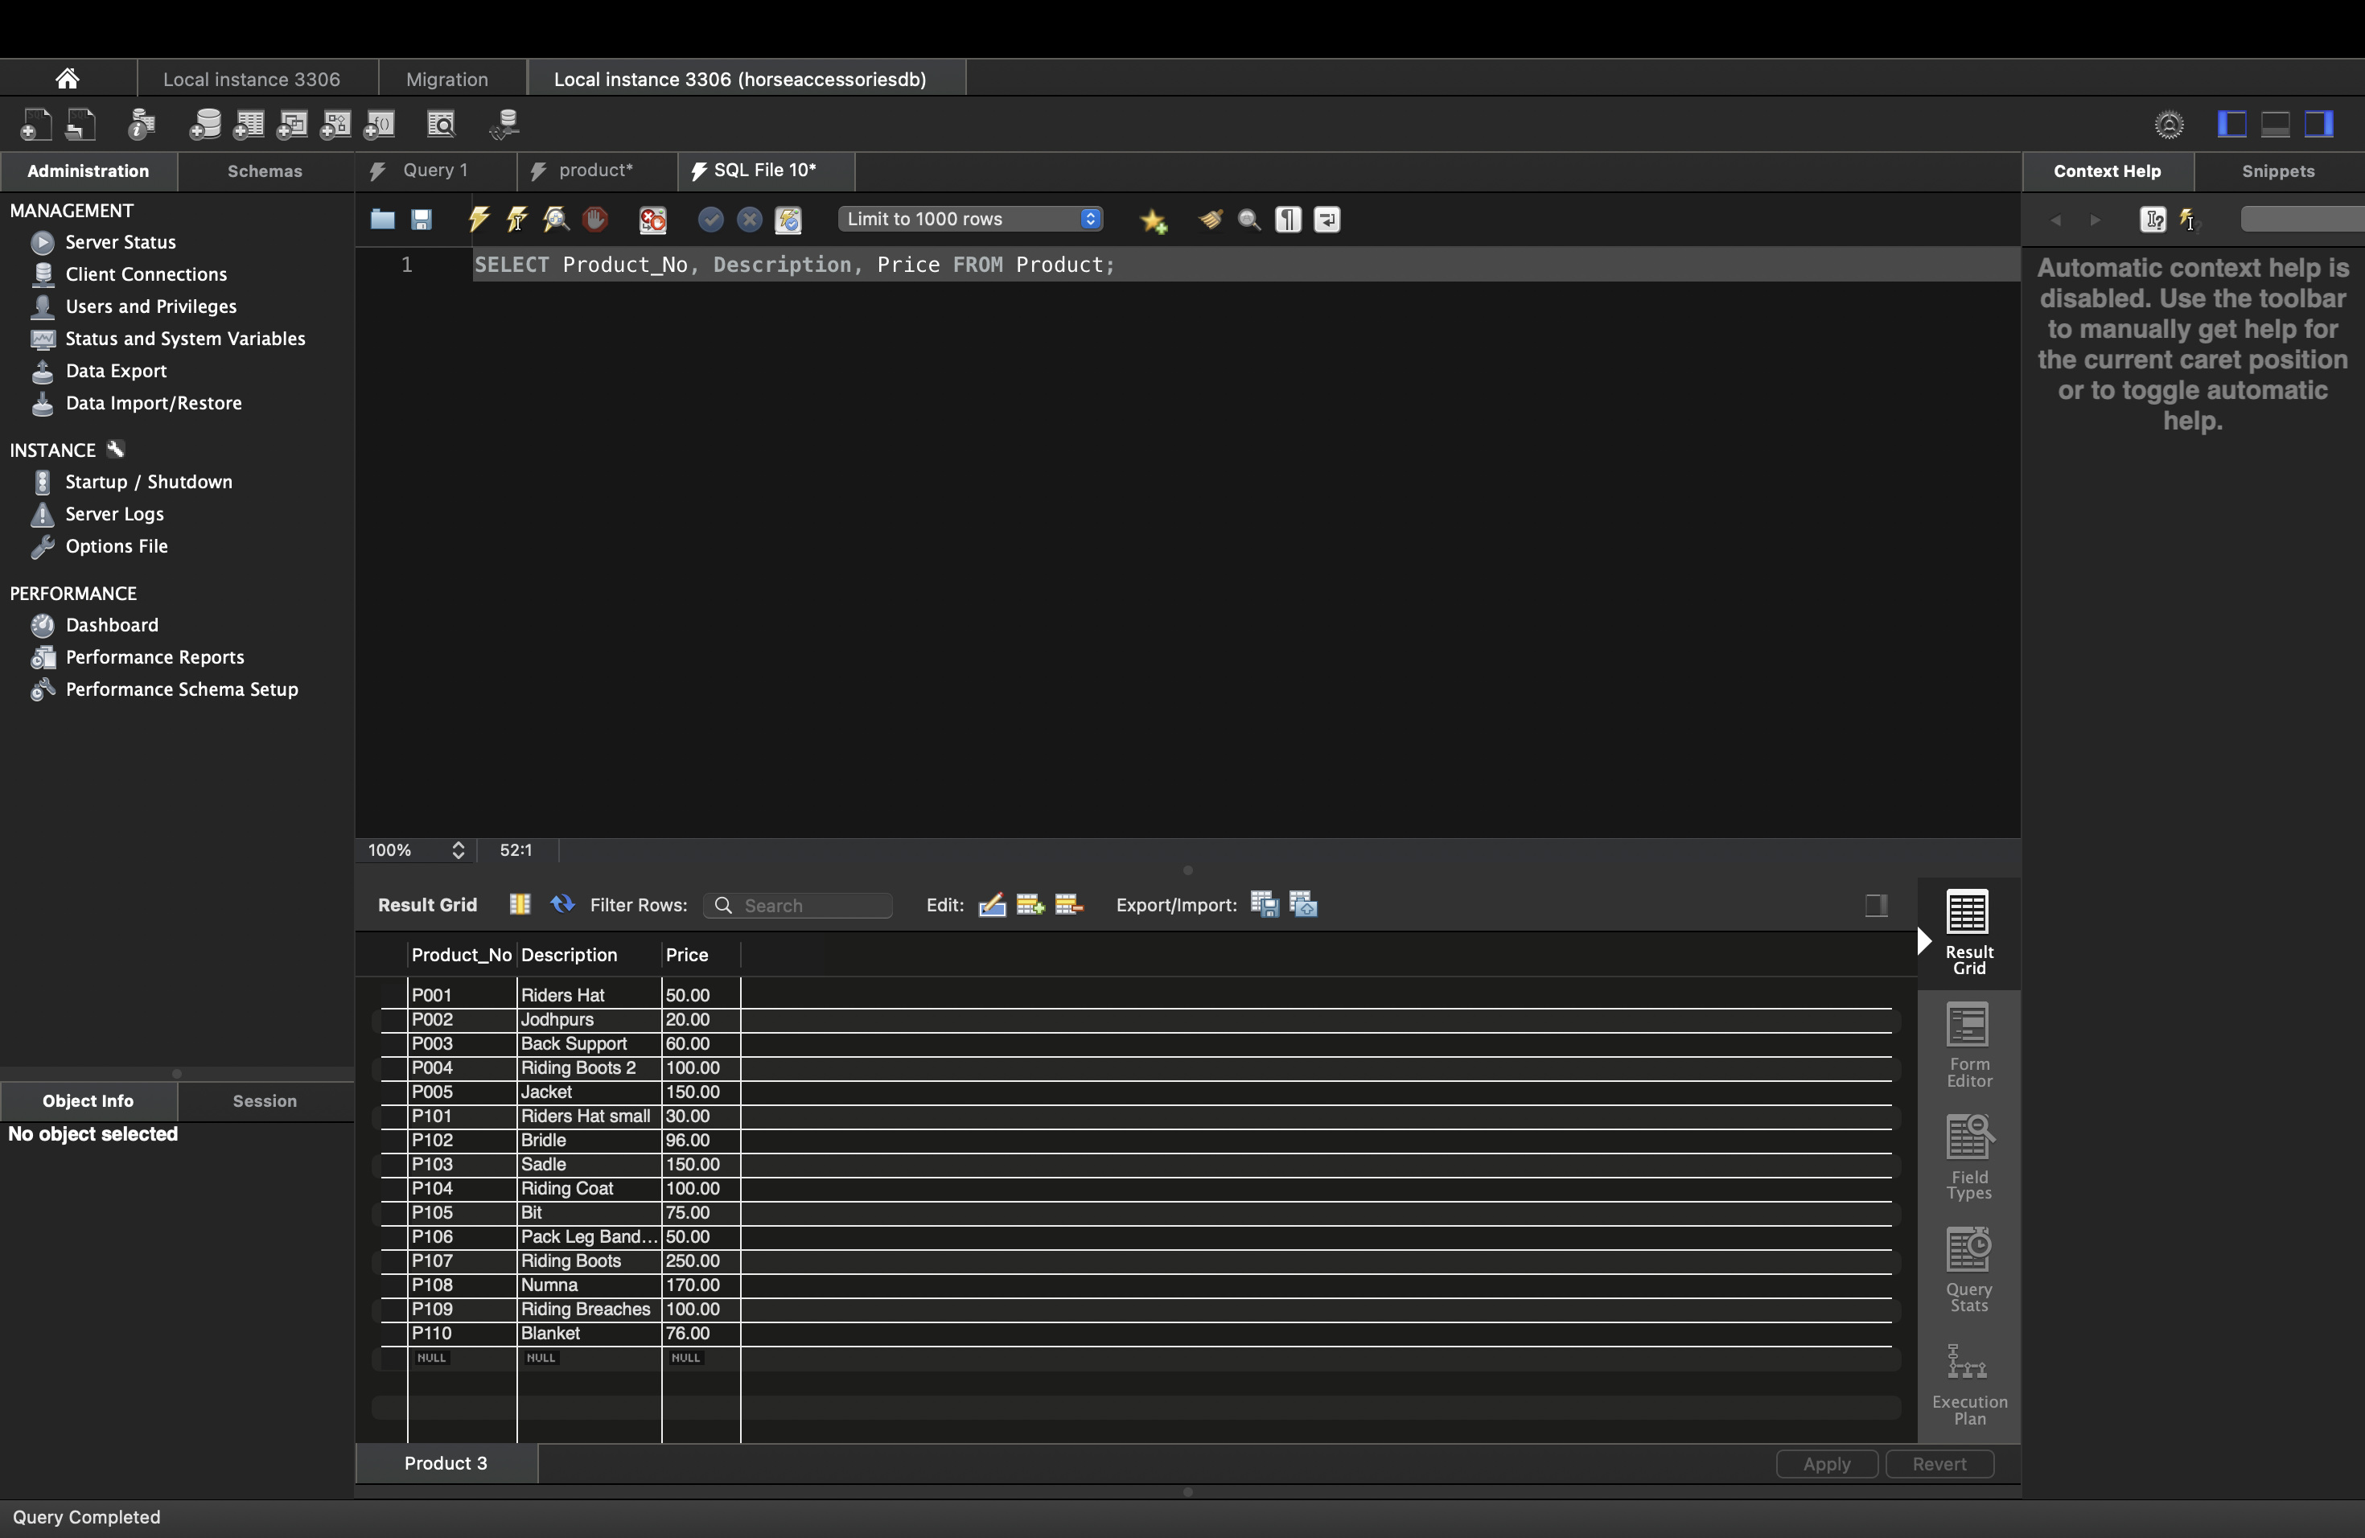

I2.8. If the following SQL command was run, how would the resultant table differ from the answer for I2.7 above: Select product_No, price, description from Product; :
Difference from I2.7:
- The column order is changed:
  - I2.7: Product_No, Description, Price
  - I2.8: Product_No, Price, Description
- Resultant table structure remains the same, only the display order of columns differs.

I2.9. Write a SQL query to “List distinct product descriptions”:
I run SELECT DISTINCT Description FROM Product;, this Ensures that duplicate descriptions are not listed.
Screenshot:
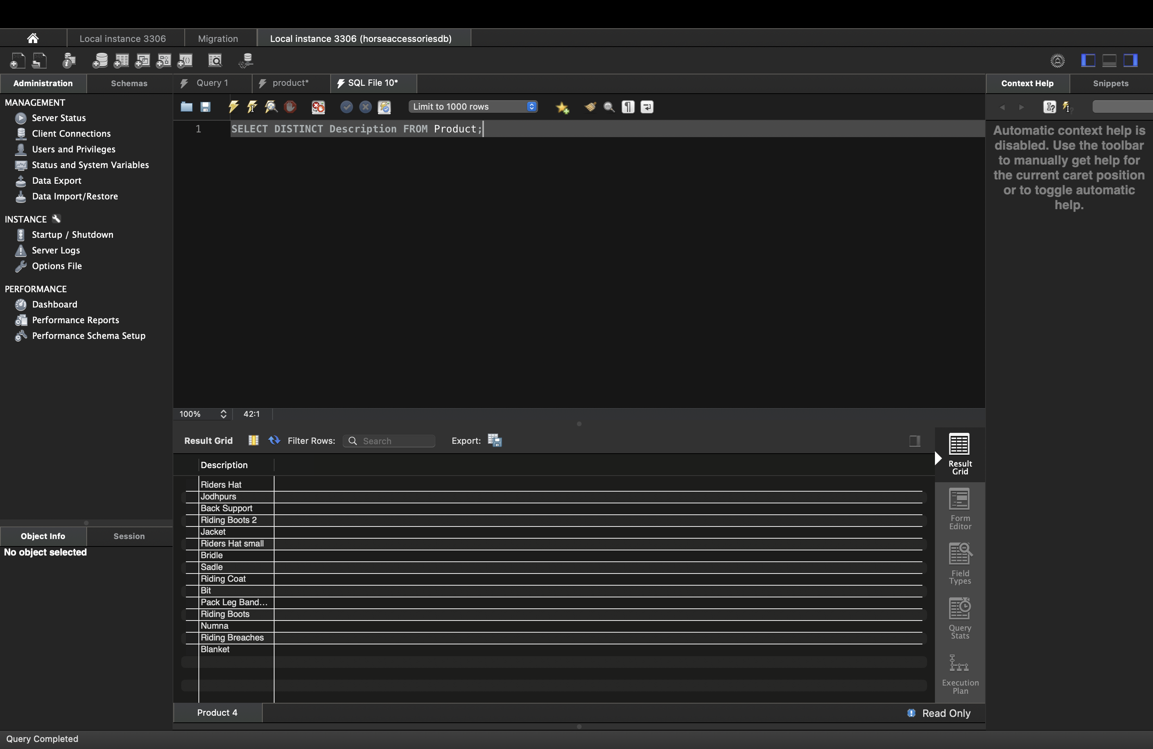

I2.10. Explain the resultant table, if the following SQL command was run:
Select distinct description, price from Product;

Answer:

It Removed any duplicate rows where both Description and Price were identical and If two products had the same description but different prices, both would be shown. If they have the same description and price, only one entry appears.

